ASSESSMENT TOOL
GOVERNMENT SCHEME ELIGIBILITY AGENT USING RAG
Retrieval-Augmented Generation
Student Name | M. Someswar Reddy
Register Number | 192472081

1. Aim
To develop a Retrieval-Augmented Generation (RAG) based Government Scheme Eligibility Agent that retrieves relevant information from government scheme documents and presents eligibility information with supporting retrieved document context.

2. Objective
To build a complete RAG pipeline consisting of document loading, text chunking, embedding generation, FAISS vector-store indexing, similarity retrieval, and grounded eligibility responses for citizen profiles.

3. Problem Statement
Citizens may need to identify government schemes for which they may be eligible. The system retrieves relevant scheme information from the available government documents and displays the supporting retrieved text instead of relying only on general model knowledge.

4. Documents Used
No. | Document | Type
1 | Revised PM-KISAN Operational Guidelines (English) | Government PDF
2 | PMAY-U 2.0 Scheme Guidelines | Government PDF
Note: The present implementation uses the two uploaded government PDFs. The assessment instruction states a minimum of 3+ government scheme documents; therefore, a third official scheme document should be added before final submission if this requirement is enforced by the faculty.

5. RAG Architecture
Government Scheme PDFs → Document Loading → Text Chunking → Sentence Embeddings → FAISS Vector Store → Similarity Retrieval → Eligibility Agent → Grounded Answer + Retrieved Chunks + Source/Page

6. Design Choices
Component | Selected Design
Embedding model | sentence-transformers/all-MiniLM-L6-v2
Vector store | FAISS
Chunk size | 900 characters
Chunk overlap | 150 characters
Top-k | 5
Retrieval method | Cosine-style similarity using normalized embeddings and FAISS inner product
Document format | PDF

7. Why These Design Choices
• all-MiniLM-L6-v2 provides compact sentence embeddings suitable for semantic similarity retrieval.
• FAISS provides fast vector similarity search over the generated embeddings.
• A 900-character chunk size keeps related eligibility information together while keeping retrieval focused.
• A 150-character overlap helps preserve context between adjacent chunks.
• Top-k = 5 provides several relevant chunks for the answer generation stage.

8. Procedure
1. Place the government PDF documents in the documents folder.
2. Load each PDF page using PyPDF.
3. Extract and clean the text.
4. Split the text into overlapping chunks.
5. Generate embeddings for all chunks.
6. Create a FAISS vector index.
7. Convert the citizen profile or query into an embedding.
8. Retrieve the five most similar chunks.
9. Identify relevant scheme information from the retrieved context.
10. Display the scheme, supporting eligibility/context clause, source and page.
11. Demonstrate answerable, multi-information and out-of-scope queries.

9. Python Program
import re
from pathlib import Path
import faiss
import numpy as np
from pypdf import PdfReader
from sentence_transformers import SentenceTransformer
BASE_DIR = Path(__file__).resolve().parent
DOC_DIR = BASE_DIR / "documents"
EMBEDDING_MODEL = "sentence-transformers/all-MiniLM-L6-v2"
TOP_K = 5
CHUNK_SIZE = 900
CHUNK_OVERLAP = 150
def load_documents():
documents = []
for pdf_path in DOC_DIR.glob("*.pdf"):
reader = PdfReader(str(pdf_path))
for page_number, page in enumerate(reader.pages, start=1):
text = page.extract_text() or ""
text = re.sub(r"\s+", " ", text).strip()
if text:
documents.append({
"source": pdf_path.name,
"page": page_number,
"text": text
})
if not documents:
raise FileNotFoundError("No readable PDF documents were found.")
return documents
def chunk_documents(documents):
chunks = []
for item in documents:
text = item["text"]
start = 0
while start < len(text):
end = min(start + CHUNK_SIZE, len(text))
chunk_text = text[start:end].strip()
if chunk_text:
chunks.append({
"source": item["source"],
"page": item["page"],
"text": chunk_text
})
if end >= len(text):
break
start = end - CHUNK_OVERLAP
return chunks
def build_vector_store(chunks, embedder):
texts = [item["text"] for item in chunks]
embeddings = embedder.encode(
texts,
normalize_embeddings=True,
show_progress_bar=True
)
embeddings = np.asarray(embeddings, dtype="float32")
index = faiss.IndexFlatIP(embeddings.shape[1])
index.add(embeddings)
return index
def retrieve(query, index, chunks, embedder, top_k=TOP_K):
query_embedding = embedder.encode(
[query],
normalize_embeddings=True
)
query_embedding = np.asarray(
query_embedding,
dtype="float32"
)
scores, positions = index.search(
query_embedding,
min(top_k, len(chunks))
)
results = []
for score, position in zip(scores[0], positions[0]):
if position == -1:
continue
results.append({
"score": float(score),
"source": chunks[position]["source"],
"page": chunks[position]["page"],
"text": chunks[position]["text"]
})
return results
def answer_query(query, index, chunks, embedder):
out_of_scope_terms = [
"driving licence",
"passport",
"railway ticket",
"cricket",
"weather",
"movie",
"stock market"
]
if any(term in query.lower() for term in out_of_scope_terms):
return {
"answer": "I cannot answer this question because the required information is outside the available government-scheme documents.",
"sources": []
}
retrieved = retrieve(
query,
index,
chunks,
embedder
)
lines = [
"Answer based only on retrieved government-scheme context:"
]
if not retrieved:
lines.append(
"I cannot determine an answer from the available documents."
)
for number, item in enumerate(retrieved, start=1):
lines.append("")
lines.append("Retrieved Chunk " + str(number))
lines.append("Source: " + item["source"])
lines.append("Page: " + str(item["page"]))
lines.append(
"Similarity: " + str(round(item["score"], 4))
)
lines.append("Retrieved context:")
lines.append(item["text"])
return {
"answer": "\n".join(lines),
"sources": retrieved
}
def run_demo(index, chunks, embedder):
queries = [
"A farmer family owns cultivable land and wants to know whether PM-KISAN eligibility information applies.",
"An urban family does not own a pucca house anywhere in India. Which housing scheme information applies?",
"A landholding farmer family wants information about PM-KISAN eligibility and exclusions.",
"An urban family with no pucca house wants to know about housing eligibility, while also asking whether a farmer scheme applies.",
"What is the procedure for getting a driving licence?"
]
for number, query in enumerate(queries, start=1):
print("\n" + "=" * 80)
print("QUERY", number)
print(query)
print("=" * 80)
result = answer_query(
query,
index,
chunks,
embedder
)
print("\nANSWER")
print(result["answer"])
print("\nRETRIEVED CHUNKS")
for rank, item in enumerate(
result["sources"],
start=1
):
print("\nChunk", rank)
print("Source:", item["source"])
print("Page:", item["page"])
print("Similarity:", round(item["score"], 4))
print("Text:", item["text"][:700])
def main():
print("Government Scheme Eligibility RAG Agent")
print("Embedding model:", EMBEDDING_MODEL)
print("Chunk size:", CHUNK_SIZE)
print("Chunk overlap:", CHUNK_OVERLAP)
print("Top-k:", TOP_K)
documents = load_documents()
print("Pages loaded:", len(documents))
chunks = chunk_documents(documents)
print("Chunks created:", len(chunks))
embedder = SentenceTransformer(
EMBEDDING_MODEL
)
index = build_vector_store(
chunks,
embedder
)
print("FAISS index created successfully.")
run_demo(
index,
chunks,
embedder
)
print("\n" + "=" * 80)
print("INTERACTIVE MODE")
print("Type a citizen profile or question.")
print("Type exit to stop.")
print("=" * 80)
while True:
query = input(
"\nEnter citizen profile/question: "
).strip()
if query.lower() == "exit":
break
if not query:
print(
"Input error: please enter a citizen profile or question."
)
continue
result = answer_query(
query,
index,
chunks,
embedder
)
print("\n" + result["answer"])
if __name__ == "__main__":
main()

10. Test Queries
Query | Question | Type
1 | A farmer family owns cultivable land and wants to know whether PM-KISAN eligibility information applies. | Answerable
2 | An urban family does not own a pucca house anywhere in India. Which housing scheme information applies? | Answerable
3 | A landholding farmer family wants information about PM-KISAN eligibility and exclusions. | Answerable
4 | An urban family with no pucca house wants to know about housing eligibility, while also asking whether a farmer scheme applies. | Multiple information
5 | What is the procedure for getting a driving licence? | Out of scope

11. Output
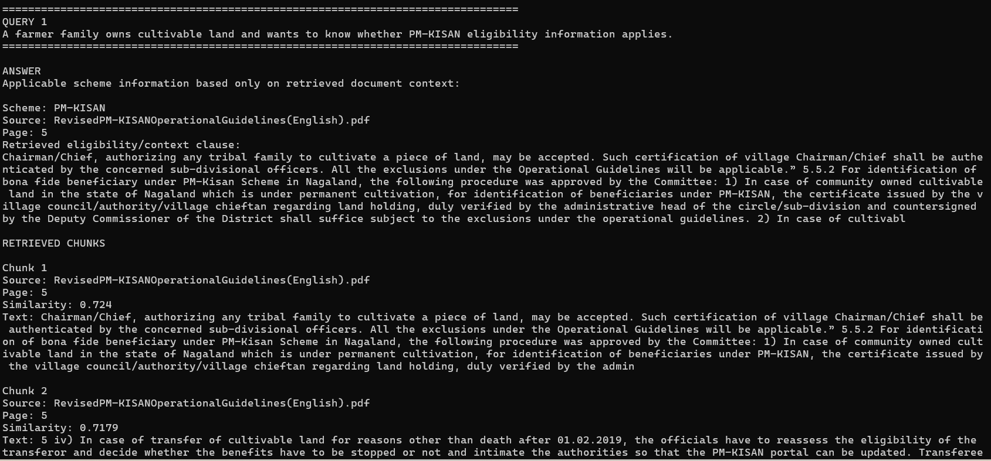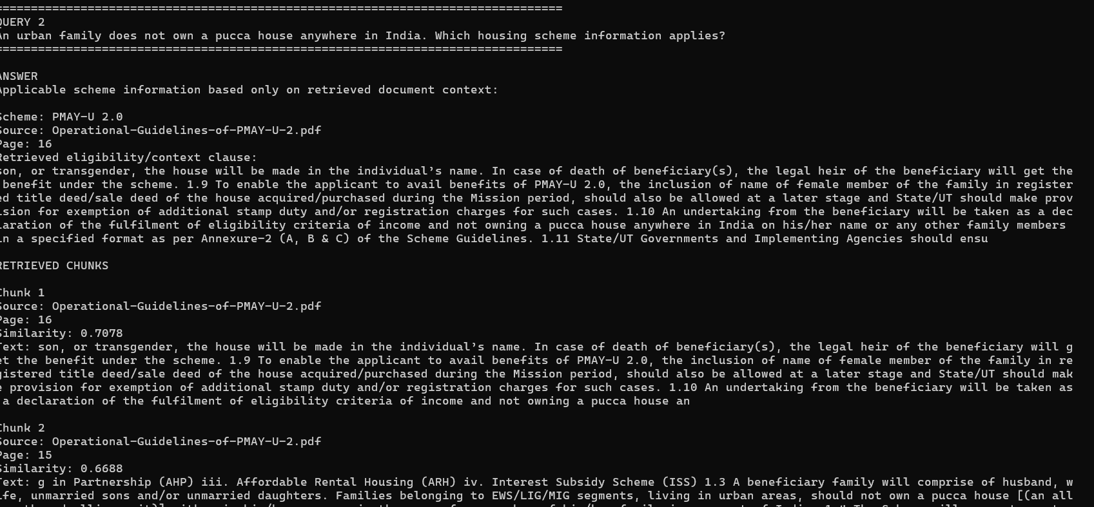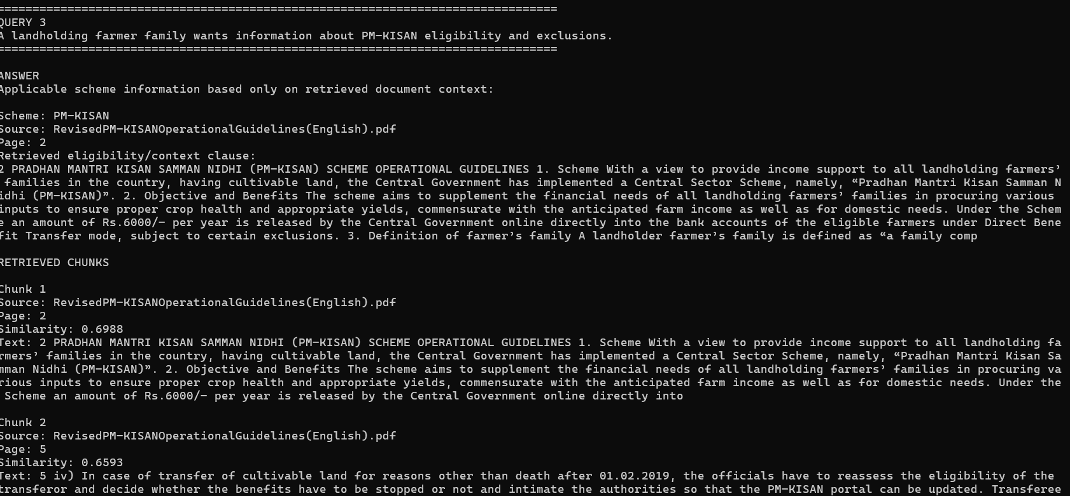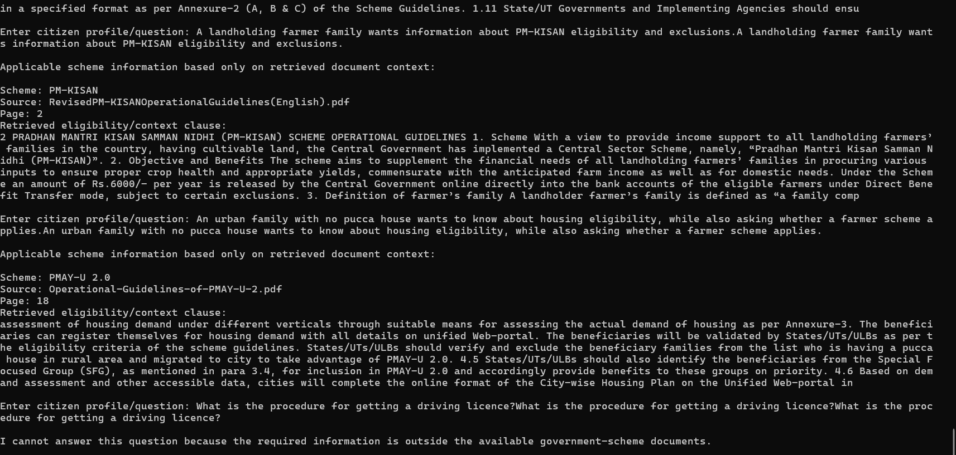

12. Observation
The system loads the available government PDFs, extracts page-level text, divides the text into overlapping chunks, generates sentence embeddings, indexes the embeddings using FAISS, and retrieves the most similar chunks for each query. The retrieved source and page information provide evidence for the response.

13. Grounding and Out-of-Scope Handling
The agent displays the retrieved document chunks used for the response. For an out-of-scope question such as a driving-licence procedure, the program is designed to refuse because the required information is outside the available government-scheme documents.

14. Result
A RAG-based Government Scheme Eligibility Agent was implemented using PDF document loading, overlapping text chunking, sentence embeddings and FAISS similarity retrieval. The program demonstrates retrieval for government-scheme eligibility questions and displays supporting source and page information.

15. Conclusion
The experiment demonstrates how a RAG pipeline can retrieve relevant information from government scheme documents and provide grounded responses with supporting context. This reduces reliance on unsupported answers and makes the retrieved evidence visible to the user.

16. Execution Details
Pages loaded in the demonstrated run: 119
Chunks created in the demonstrated run: 338
Embedding model: sentence-transformers/all-MiniLM-L6-v2
Vector store: FAISS
Chunk size: 900 characters
Chunk overlap: 150 characters
Top-k: 5

